**AI - Based Natural Disaster Intensity Analysis**

**Team members**

* Koushik Rachaputi
* Abhishikth Aryasomayajula
* Doma Pratheek
* Varun Bukkala
* G.S.V.Sathwik

**INTRODUCTION:**

Natural disasters not only disturb the human ecological system but also destroy the properties and critical infrastructures of human societies and even lead to permanent change in the ecosystem. Disaster can be caused by naturally occurring events such as earthquakes, cyclones, floods, and wildfires. Many deep learning techniques have been applied by various researchers to detect and classify natural disasters to overcome losses in ecosystems, but detection of natural disasters still face issues due to the complex and imbalanced structures of images. To tackle this problem, we developed a multilayered deep convolutional neural network model that classifies the natural disaster and tells the intensity of disaster of natural the model uses an integrated webcam to capture the video frame and the video frame is compared with the Pre trained model and the type of disaster is identified and highlighted on the OpenCV.

**Problem Statement:**

Earlier we focus on post disaster relief and rehabilitation measures. Now the focus is shifted. As per sec.2(e) of DM Act 2005, Disaster Management means a coordination and integrated process of planning, organizing, coordinating, and implementing measures which are necessary or expedient for-

(i) Prevention of danger or threat of any disaster

(ii) Preparedness to deal with any disaster

(iii) Prompt response to any threatening disaster situation or disaster

(iv) Assessing the severity or magnitude of effects of any disaster

(v) Evacuation, rescue, and relief

(vi) Rehabilitation and reconstruction

**Solutions:**

**Prevention:**

Action within this segment is designed to impede the occurrence of a disaster event and/or prevent such an occurrence having harmful effects on communities or key installation**s.**

**Mitigation:**

Action within this segment usually takes the form of action within this segment usually takes the form of specific programs intended to reduce the effects of disaster on a nation or community. For instance, some countries regard the development and application of building codes (which can reduce damage and loss in the event of earthquakes and cyclones) as being in the category of mitigation.

**Preparedness:**

Preparedness is usually regarded as comprising measures which

enable governments, organizations, communities, and individuals

to respond rapidly and effectively to disaster situations.

**Literature survey**

1)Published in: 2015 International Conference on Circuits, Power and Computing Technologies [ICCPCT-2015] Date of Conference: 19-20 March 2015 Date Added to IEEE Xplore: 16 July 2015 Data mining offers immense potential benefits for GIS (Geographic Information System) based decision making. Spatial databases store two types of data: raster data (satellite/aerial digital images) and vector data (points, lines, polygons). Need of Spatial database. To store and query data that represents objects defined in a geometric space. To handle more complex structures such as 3Dobjects, topological coverages.

2)Tun Lin Moe , Fritz Gehbauer , Stefan Senitz , Marc Mueller Disaster Prevention and Management ISSN: 0965-3562 Article publication date: 13 November 2007 With the recognition of the necessity for effectively and successfully managing natural disaster projects for saving human lives and preventing and minimizing the impacts of disasters on socio‐economic developmental progress, this paper seeks to propose a balanced scorecard (BSC) approach to maximize the possibilities of desired outcomes from Projects.

**Experimental Investigations:**

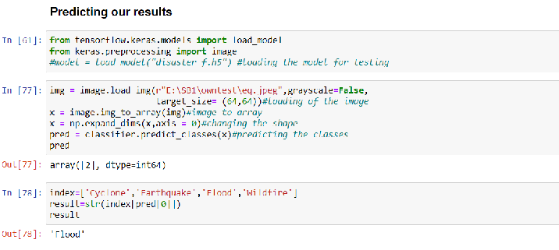

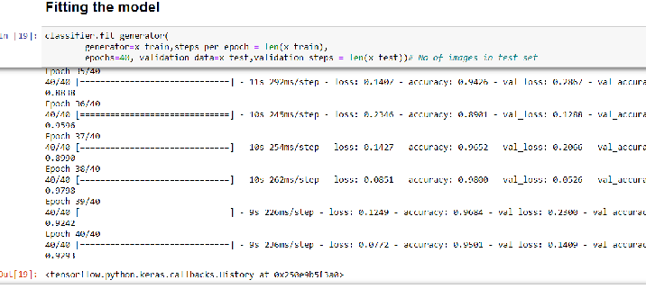

**Results:**

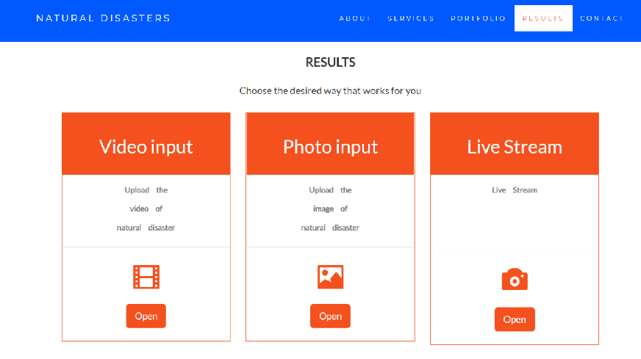

**Image and video input:**

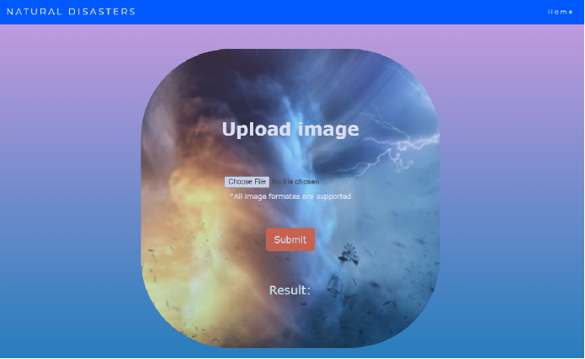

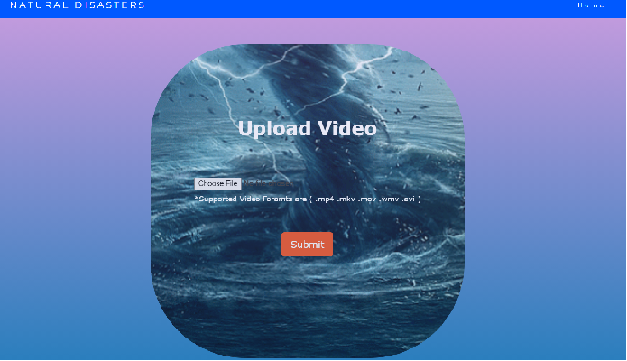

**Outputs:**

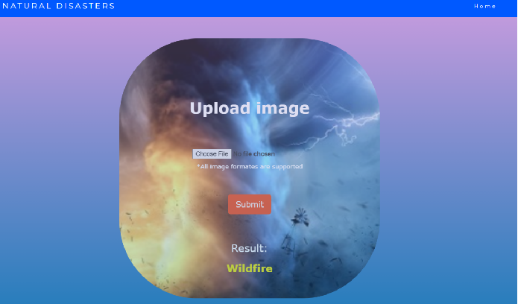

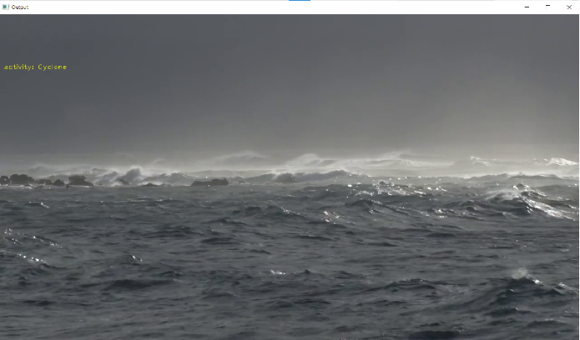

**Hardware and Software Specification's:**

Software Requirements:

• Python (3.7 or older)

• Anaconda Prompt

• Jupyter Notebook

• OpenCV

• CNN

• Keras

• TensorFlow

• Flask

**Hardware Requirements :**

• Processor: Minimum 1 GHz; Recommended 2GHz or more.

• Ethernet connection (LAN) OR a wireless adapter (Wi-Fi)

• Hard Drive: Minimum 32 GB; Recommended 64 GB or more.

• Memory (RAM): Minimum 1 GB; Recommended 4 GB or above.

**FlowChart:**

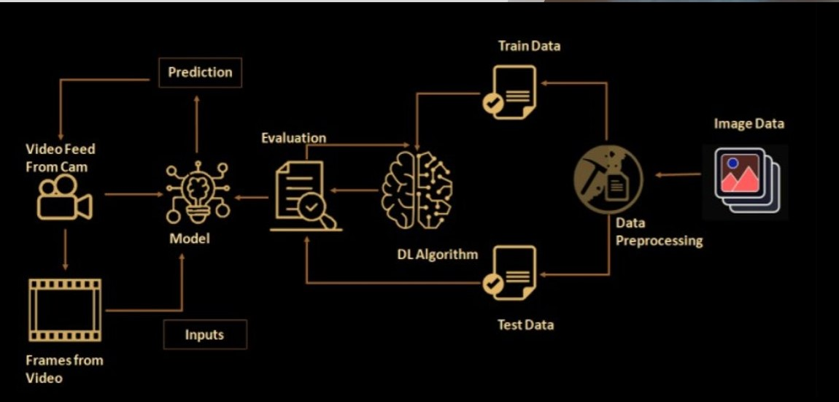

**Conclusion:**

• The natural disaster in Indonesia frequently happened, due to the geographical position of the country.Thus, natural disasters mostly occurred as an impact of the natural condition. However, the weather and climate condition has also influenced and triggered the disasters.

**Future Scope:**

In the future, the research will be continued to obtain the data from all over the country, not only west java province, and with the use of more complete analysis, so that the government or related institution could make a better anticipation work as a mitigation effort.

**Bibliography:**

• CHENG Li-hai1, TANG Hong3,4, ZHOU Ting-gang1,2, ZHANG Lu3,5, ZHANG Min1.Evaluation method of natural disaster intensity and its application. • Muhammad Aamir 1, Tariq Ali 1, Muhammad Irfan 2, Ahmad Shaf 1, Muhammad Zeeshan Azam 3, Adam Glowacz 4, Frantisek Brumercik 5, Witold Glowacz 4, Samar Alqhtani 6 and Saifur Rahman 2: Natural Disasters Intensity Analysis and Classification Based on Multispectral Images Using Multi-Layered Deep Convolutional Neural Network

• https://pdfs.semanticscholar.org/c1bb/6a735f421b950d25eaf85e1044801d26e97d.pdf%E2%80%8B

• Andi Wahju Rahardjo Emanue, Rania Rizki Arinta: Natural Disaster

Application on Big Data and Machine Learning: A Review,

• https://www.researchgate.net/publication/337444578_Natural_Disaster_Application_on_Big_Data_and_Machine_Learning_A_Review

• P. K. Freeman, M. Keen, and M. Mani, “Being prepared,” Finance Dev., vol. 40, no. 3, pp. 42–5, 2003.